

Foundations of Programming

Assignment No. : 06
PROBLEM STATEMENT:Write a C function to compute the factorial of a number with and without recursion.

OBJECTIVE:

To demonstrate two different approaches for calculating the factorial of a number: iterative (non-recursive) and recursive, showcasing the versatility of problem-solving methods in programming.

THEORY:

1) Difference between iterative and recursive approaches
The iterative approach calculates factorial using a loop (like for or while). It repeatedly multiplies numbers from 1 to n until the result is obtained. This method is faster and uses less memory because it does not involve function calls.
The recursive approach calculates factorial by calling the same function again with a smaller value (n-1). It breaks the problem into smaller parts until it reaches a stopping condition. This method is easy to understand and shorter to write, but it uses more memory due to multiple function calls.
In short:
- Iterative → uses loops, efficient
- Recursive → uses function calls, simpler but memory heavy

2) What is the base case and why is it necessary?
The base case in a recursive factorial function is:
- factorial(0) = 1
- factorial(1) = 1
It is necessary because:
- It stops the recursion
- Prevents infinite function calls
- Provides a final value from which the calculation builds up
Without the base case, the function would keep calling itself forever and the program would crash.

3) Handling invalid input (negative numbers)
Factorial is not defined for negative numbers, so the program checks if the input is negative.
- If n < 0, the program prints an error message like:
"Factorial is not defined for negative numbers"
- It does not perform the calculation
This is important because:
- It prevents incorrect results
- Avoids logical errors
- Makes the program safe and reliable

PLATFORM: Linux
Algorithm:
(A) Non-Recursive
- Start
- Declare variables n, i, and fact
- Initialize fact = 1
- Read the value of n from the user
- Check if n < 0
  - If yes, print "Factorial is not defined for negative numbers" and stop
- Else, repeat the loop from i = 1 to n
  - Multiply fact = fact × i
- After the loop ends, display the value of fact
- Stop
(B) Recursive Factorial
- Start
- Read the value of n from the user
- Check if n < 0
  - If yes, print "Factorial is not defined for negative numbers" and stop
- Else call function factorial(n)
Function factorial(n):
- If n == 0 or n == 1
  - Return 1 (Base Case)
- Else
  - Return n × factorial(n - 1)
- Display the result returned by the function
- Stop

INPUT:
- Non-Recursive approach

#include <stdio.h>

long long int factorial_iterative(int n) {
long long int fact = 1;
int i;

for (i = 1; i <= n; i++) {
fact = fact * i;
}

return fact;
}

int main() {
int n;

printf("Enter a number: ");
scanf("%d", &n);

if (n < 0) {
printf("Factorial is not defined for negative numbers.\n");
} else {
printf("Factorial (Iterative) = %lld\n", factorial_iterative(n));
}

return 0;
}

- Recursive Approach
#include <stdio.h>

long long int factorial_recursive(int n) {
if (n == 0 || n == 1) {
return 1; // Base case
} else {
return n * factorial_recursive(n - 1);
}
}

int main() {
int n;

printf("Enter a number: ");
scanf("%d", &n);

if (n < 0) {
printf("Factorial is not defined for negative numbers.\n");
} else {
printf("Factorial (Recursive) = %lld\n", factorial_recursive(n));
}

return 0;
}

OUTPUT:
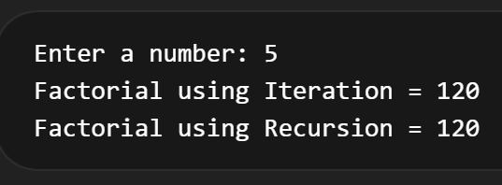

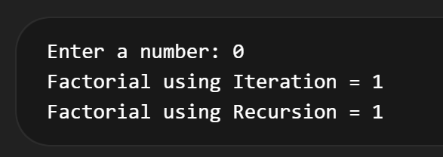

CONCLUSION: Thus, we have successfully executed factorial of a number with and without recursion.

FAQs:
1. What is the purpose of calculating factorial in programming?
2. What is the difference between recursive and non-recursive (iterative) methods?

